# **Compass - Case Details Landing Page**

Case Details Landing Page

Case Details Panel

Navigational Tabs

Left Panel

Center Panel

Right Panel

Related Documents

**Description:** Details regarding the Case Details Landing Page in Compass.

|  |
| --- |
| Case Details Landing Page |

The **Case Details Landing Page** contains five components:

* Case Details Panel
* Navigational Tabs
* Left Panel
* Center Panel
* Right Panel

 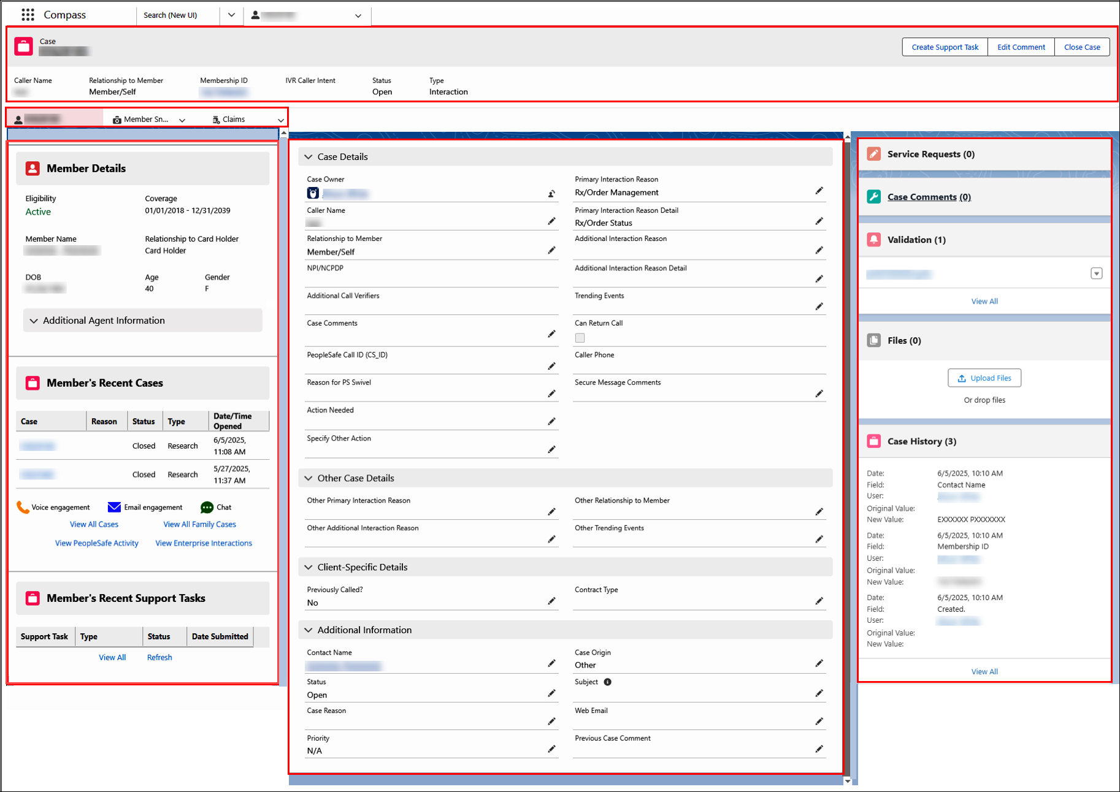

Top of the Document

|  |
| --- |
| Case Details Panel |

The **Case Details** **Panel** displays details about the current case, and remains visible at the top of the page throughout the duration of the call.

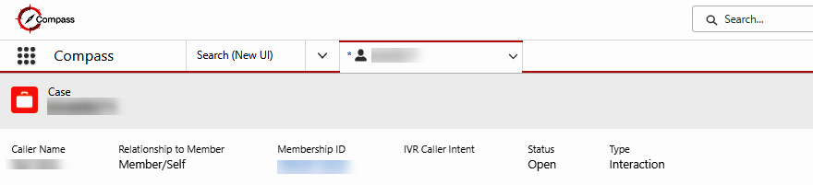

Top of the Document

|  |
| --- |
| Navigational Tabs |

The **Navigational Tabs** are located below the Case Details Panel. These tabs will remain available while the case is open and cannot be closed by the user.

There are three Navigational Tabs:

* Case Details
* Member Snapshot
* Claims Landing Page

**Note:** The tab you are on will appear pink and the tab name will be underlined:

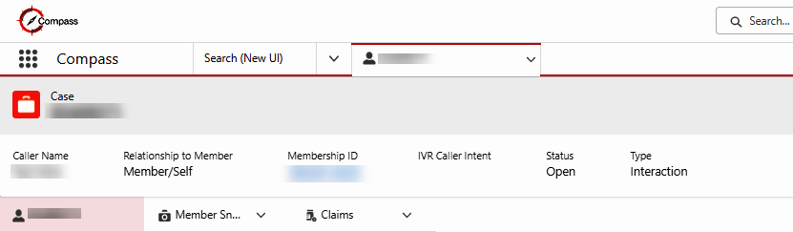

Top of the Document

|  |
| --- |
| Left Panel |

The **Left Panel** contains the following:

* **Member Details:** The member details section displays member demographics.

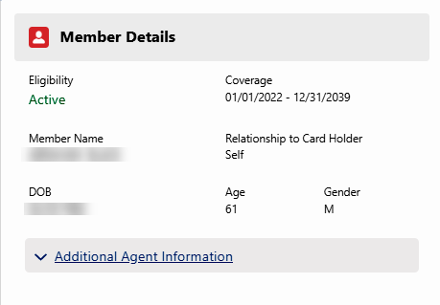

* **Member’s Recent Cases:** Shows the members most recent cases.

Click on the Case number to retrieve more information about previous cases.

**Notes:**

* + The icons in the screenshot below indicate the method of contact—Voice, Email, and Chat; additionally,
  + by clicking on “**View All Cases,”** you can find the same information in text format under the “Case Origin” column.
  + Clicking on **View All Family Cases** will display **Member Journey** screen with **View by Member or Family** field populated with **Family**.

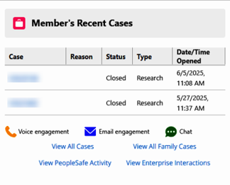

**View All Cases**

**View All Family Cases**

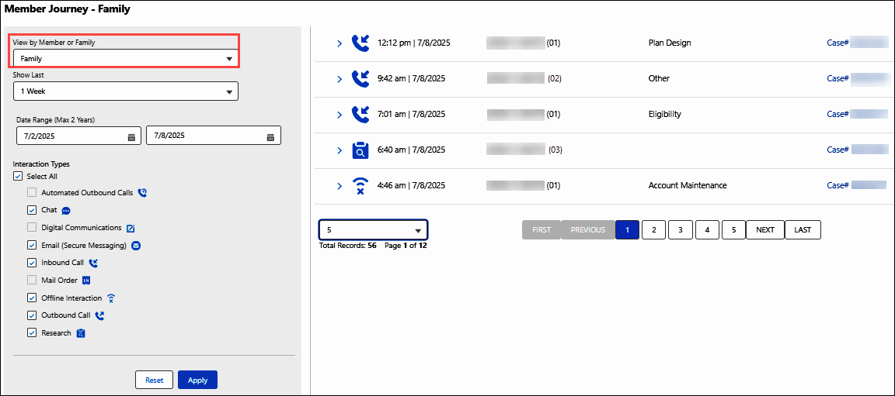

* **Member’s Recent Support Task:** Displays the member’s most recent Support Tasks. Click **Refresh** hyperlink to view recently submitted Support Tasks as needed.

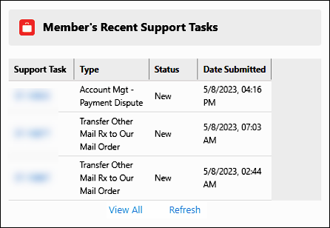

Top of the Document

|  |
| --- |
| Center Panel |

The **Center Panel** contains the following collapsible sections:

* Case Details
* Other Case Details
* Client-Specific Details

http://sharepoint/sites/opscom/Operations%20Communication/Formatting/Icon%20-%20Important%20Information.png **Do not edit or enter information into these sections. The information found on the Case Details screen comes from multiple locations and sources.**

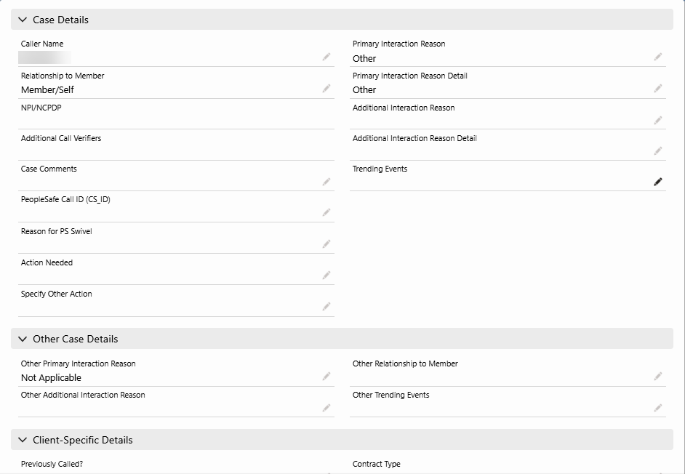

The information below provides details, listed in the order each item displays on the screen. Information that is automatically collected does not require additional Notes when documenting the call.

|  |  |
| --- | --- |
| **Field** | **Source of Information Displayed** |
| **Caller Name** | Captured from Who is Calling panel, Authentication screen; entered by agent |
| **Relationship to Member** | Captured from Who is Calling panel, Authentication screen (defaults to retail); entered by agent |
| **Contact Name (Member Name)** | Captured from Authentication screen; entered by agent |
| **Status** | Captured by CRM - dynamic field describing the current Case status; system generated |
| **Priority** | Not currently used |
| **Case Origin** | Not currently used |
| **Subject** | Not currently used |
| **Previous Case Comment** | Captured from Call Documentation Notes. |
| **Primary Call Reason (Interaction)** | Captured from Interaction Information panel, Case tab; entered by agent |
| **Additional Interaction Reasons** | Captured from Interaction Information panel, Case tab; entered by agent |
| **Trending Events** | Captured from Interaction Information panel, Case tab; entered by agent |
| **Other Documentation** | Not currently used |
| **ANI** | Captured by IVR; system generated information (phone number) |
| **Type** | Captured either from Authentication screen (Interaction) **OR** entered by agent (Research) |
| **Case Reason** | Not currently used |
| **Global Identifier (Transaction ID number)** | Captured by CRM; system generated |
| **Membership ID** | Captured from Who is Calling panel, Authentication screen; entered by agent |
| **IVR Caller Intent** | Captured via the IVR or selected by the caller; system generated |
| **Web Email** | Not currently used |
| **Previously Called ?** | Not currently used |
| **Activities** | Captured from Interaction Information panel, Case tab; entered by agent |
| **Date/Time Opened** | Captured by CRM; system generated |
| **Date/Time Closed** | Captured by CRM; system generated |
| **Contract Type** | For future use |
| **Pharmacy NPI** | Captured from Who is Calling panel, Authentication screen; IVR generated **OR** entered by agent |

Top of the Document

|  |
| --- |
| Right Panel |

The **Right Panel** contains Service Requests and Case Comments within the Related section.

**Note:** Case comments entered in the Case Comments pop up will display in this section.

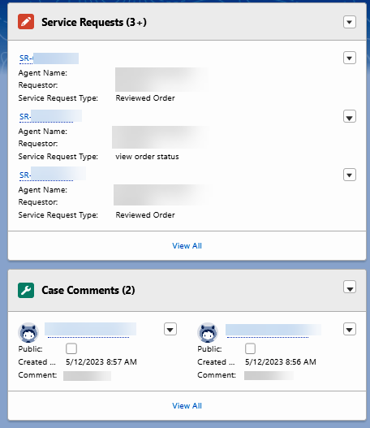

Top of the Document

|  |
| --- |
| Related Documents |

[Customer Care Abbreviations, Definitions, and Terms Index (017428)](https://thesource.cvshealth.com/nuxeo/thesource/#!/view?docid=c1f1028b-e42c-4b4f-a4cf-cc0b42c91606)

Top of the Document

Not to Be Reproduced or Disclosed to Others without Prior Written Approval

**ELECTRONIC DATA = OFFICIAL VERSION / PAPER COPY = INFORMATIONAL ONLY**